**ATM SIMULATOR SYSTEM**

**New Account Application Form:**

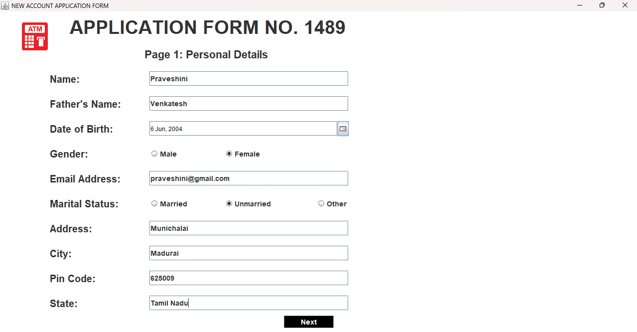

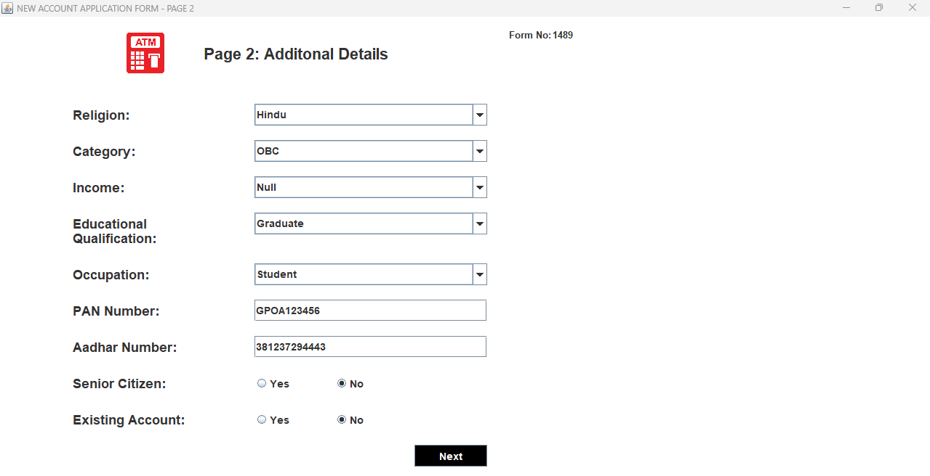

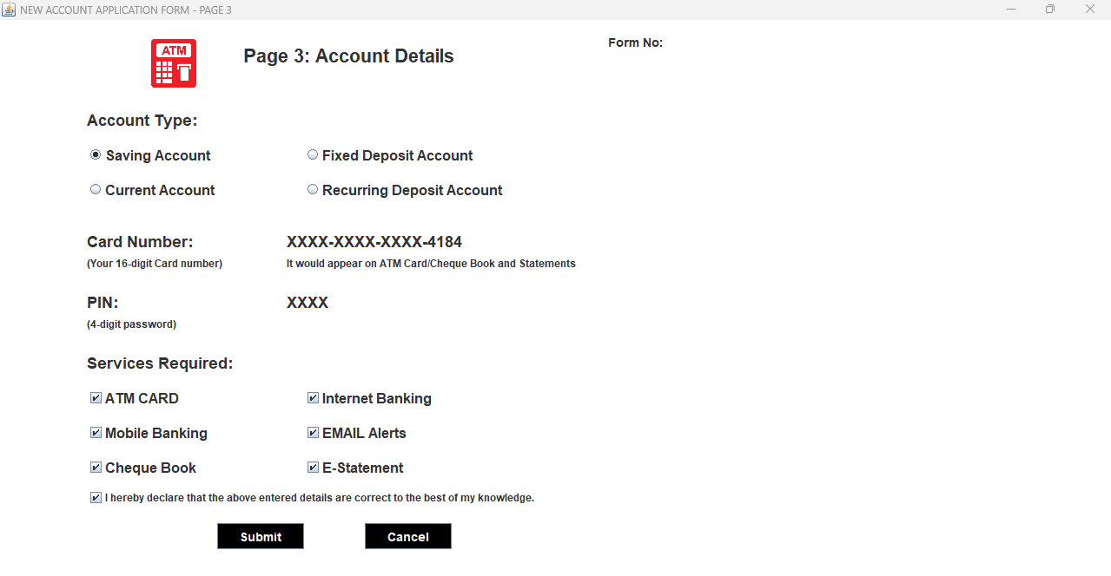

**CARD NUMBER AND PIN GENERATION**

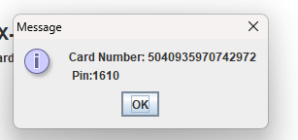

**DEPOSIT:**

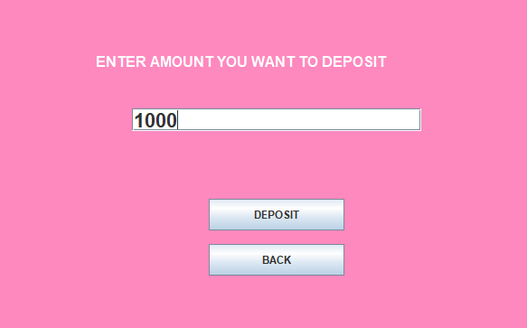

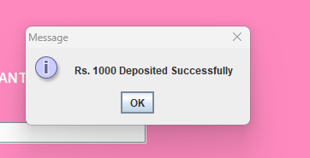

**ATM TRANSACTION OPERATION SELECTION:**

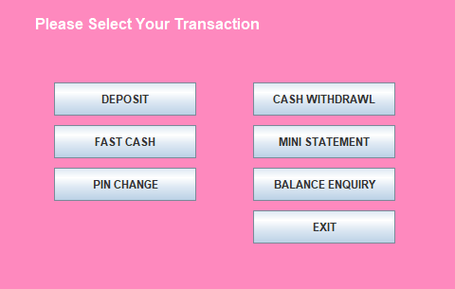

**FAST CASH:**

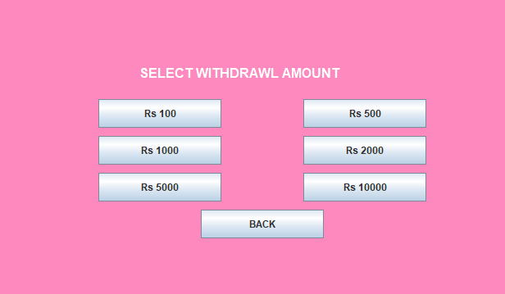

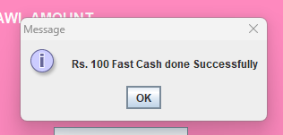

**PIN CHANGE:**

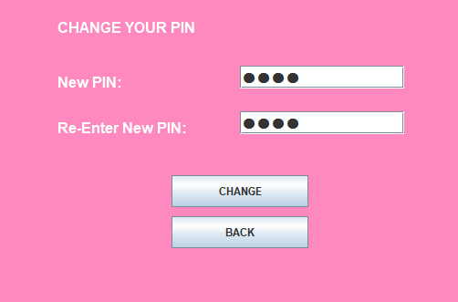

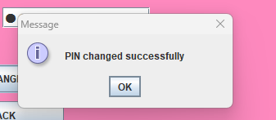

**WITHDRAWAL:**

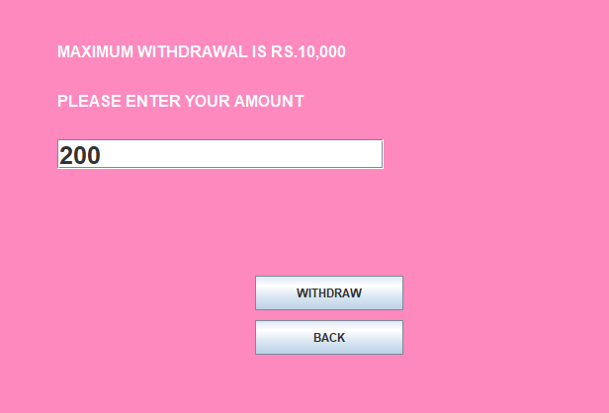

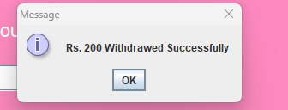

**BALANCE CHECKING:**

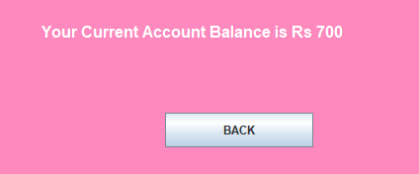

**MINI STATEMENT GENERATION:**

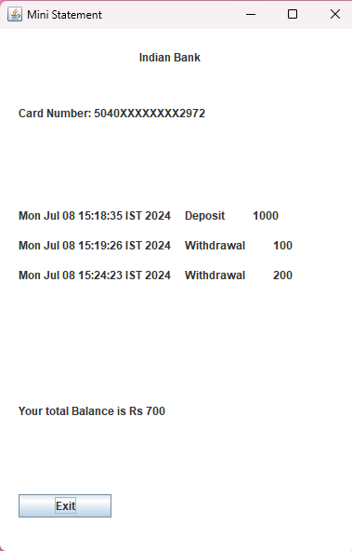

**Data Base:**

**Signup Table:**

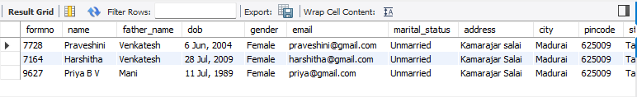

**Login Table:**

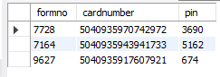

**Bank Transaction Details Table:**

